- October, 2019  10% off  your next stay  The leaves are changing colors and have been FALLing from the trees! Come enjoy a serene stay in the middle of nowhere; catch a glimpse of the birds flying south and the leaves in their annual beauty.  Call us soon to reserve your suite before December 31, when the Fall discount ends. | Simply Shane  Welcome  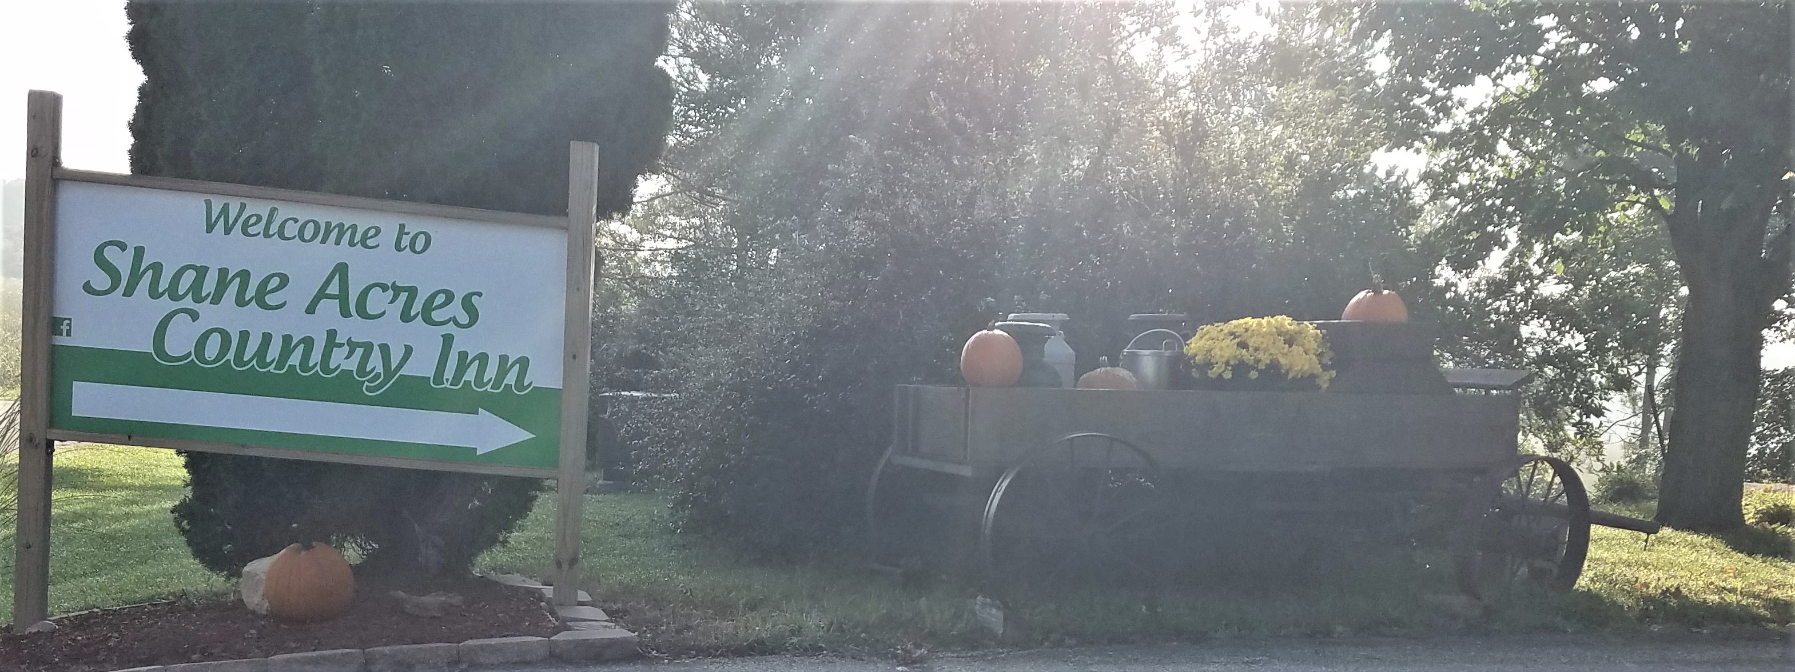  Shane Acres Country Inn Bed and Breakfast has formally been in business for 1 year and 6 months! It’s about time we put together a newsletter to keep all of you informed of our monthly adventures as well as our monthly discounts.  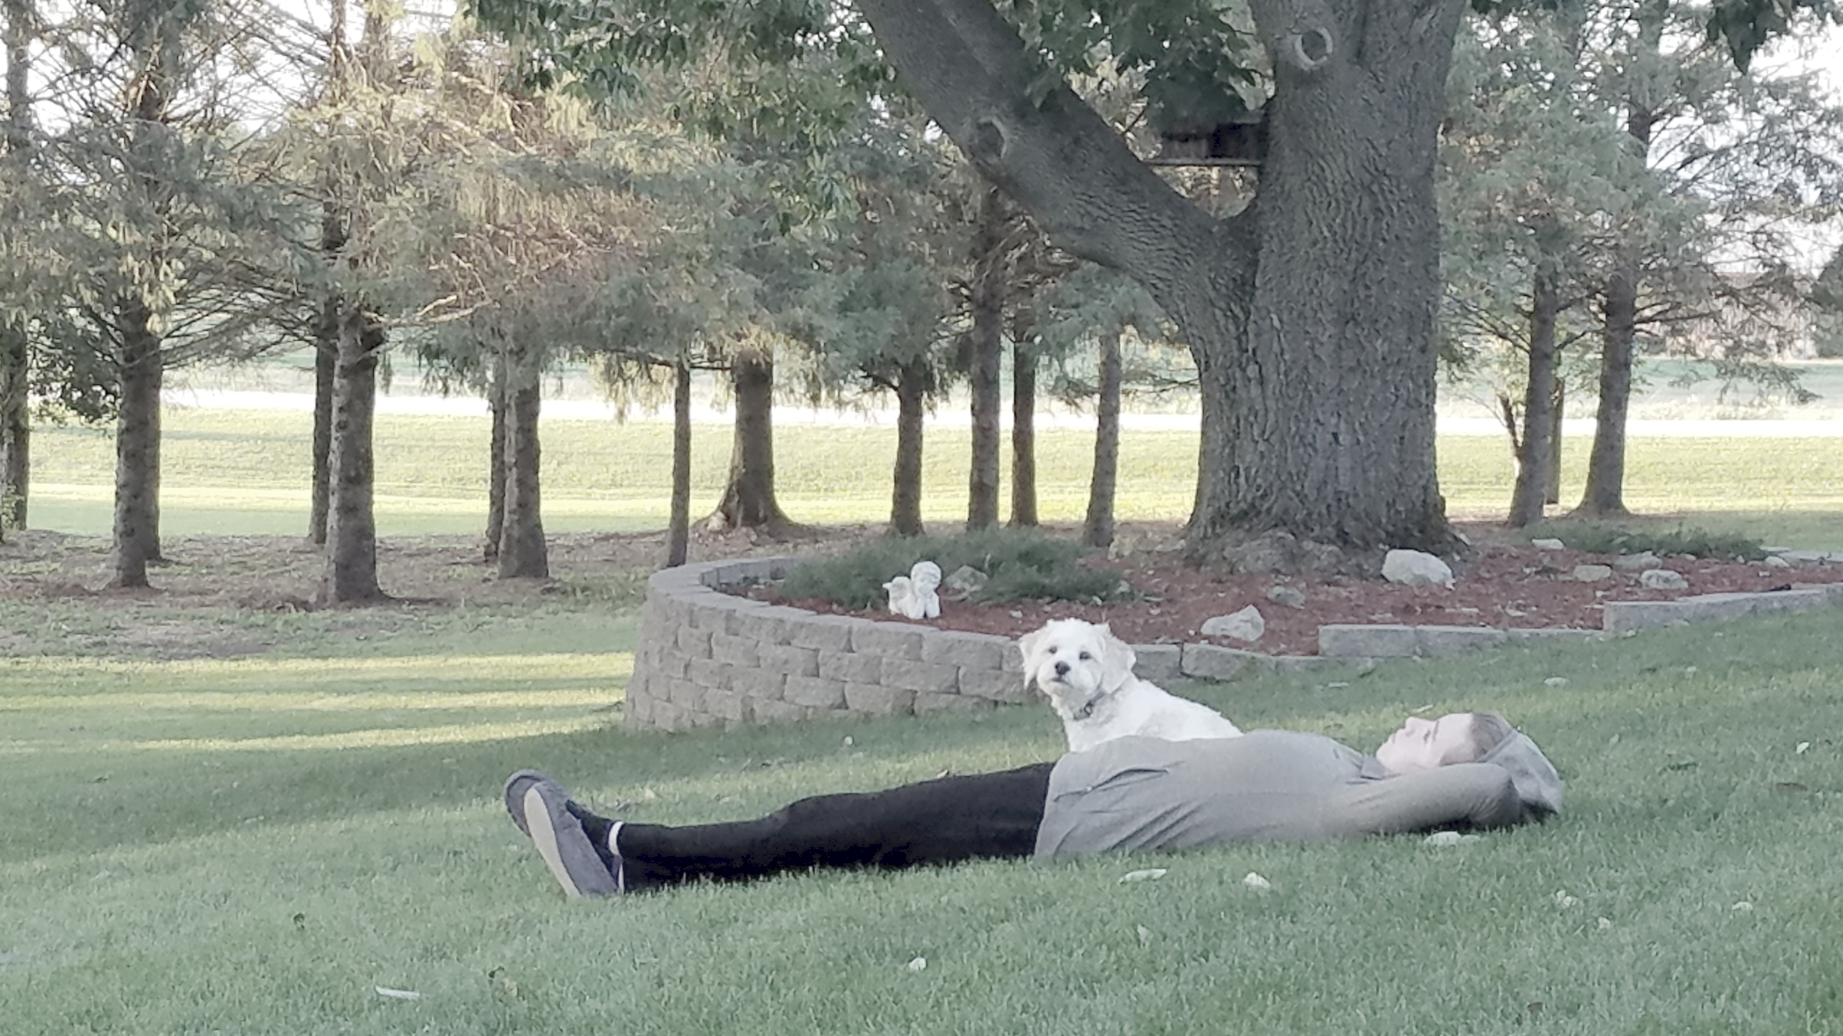  A girl and her dog  "Wait, don't move, I want to take your picture!" I yelled at Jacqueline as I opened the sliding glass doors! There she was, laying on her back watching the leaves change color.  This could be you!  From the rest of 2019 you can stay here for 10% off. Just call us and let us know you found us on social media!  See you soon!
- Contact Us  Shane Acres Country Inn  Bed and Breakfast  N4589 Primrose Lane  Juneau, WI 53039  920-341-3004  shaneacresllc@gmail.com  www.shaneacrescountryinn.com  - Social Media  https://www.facebook.com/pg/shaneacrescountryinn/  https://www.instagram.com/shaneacrescountryinn/ | Frequently Asked Questions  Q. May I bring my dog?  A. Absolutely! In fact, we have two dogs and 2(ish) cats who live with us. We have a 15-year-old cairn terrier named Harley and a 1-year-old cockapoo named Luigi. An 8-year-old long-haired cat named Turbo lives in the house and an unknown aged feral cat named Mario lives outside. When you stay with us, we’d love to share that story with you!  Q. Where is a good place to eat?  A. That depends on what you’re looking for. The closest restaurants are in Juneau, about 4 miles from here. You will find a pizza place called Rollin’ Stone, a bar and grill called Barrel House, a family diner called Village Garden, or the popular Subway. Or just stop at Piggly Wiggly, pick up your own steaks or burgers and bring them back here to grill outdoors.  Q. I’m gluten free, may I still eat breakfast with you?  A. Absolutely! We have a great gluten-free pancake mix; add some bacon, scrambled eggs, and fresh fruit and you have a filling, delicious breakfast when you wake up!  “Lovely country place, the outdoor plantings were awesome and the hospitality was great.” -Linda  Local Events:  October 3, 9:00-1:00 Fall Senior Expo – Central Wisconsin Christian School Waupun  October 4, 10:00 AM Wisconsin Antique Dealers Association Show – Waukesha Community Expo Center  October 5, 8:00-12:00 Lomira’s Fall Farmer’s Market Pancake Breakfast – Lomira Municipal Building  October 5 (Every Saturday), 6:15-1:45 PM Dane County Farmer’s Market – Capitol Square, Madison  October 10, 7:00 PM Fall Fashion Extravaganza – Old Hickory Golf Club  October 12, 7:30 PM Starkweather Bay Blues Band – Beaver Dam Area Community Theatre  October 18, 7:30 PM The Laramie Project – Beaver Dam Area Community Theatre Fine Arts Center  October 19, 8:00-12:00 Dodge County Flea Market and Craft Fair – Dodge County Fair Grounds

