- December, 2019  10% off  your next stay  The snow is falling (has fallen) and the scenery is amazing! Come enjoy a serene stay in the middle of nowhere.  Call us soon to reserve your suite before December 31, when the Fall discount ends.  “What a super relaxing place, my week was outstanding!”  -Anonymous  - Social Media  https://www.facebook.com/pg/shaneacrescountryinn/  https://www.instagram.com/shaneacrescountryinn/ | Simply Shane  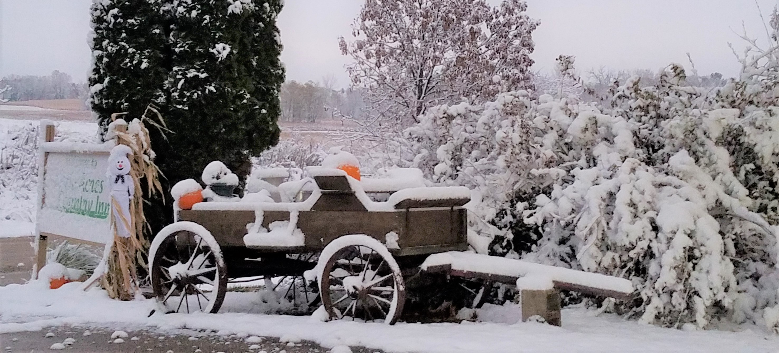  . . . The triple beat of two feet and a  crutch came down the hall,  The rattle of the china  in the hutch against the wall.  She poured two cups. She smiled and then she handed one to me.  And then we settled back and had  a cup of Christmas tea.  As he ended the recitation of this entire poem (over 900 words), our guest shook our hands and turned to leave. We were left in awe, our mouths hanging open. This first-time guest had just regaled us with a theatrical retelling of A Cup of Christmas Tea by Tom Hegg. Tom Hegg wrote this poem in 1982 after his pastor asked him to write something for his church’s 125th anniversary. I encourage you to find the poem online, it has so much feeling and emotion in it you can hear the teacups clattering.  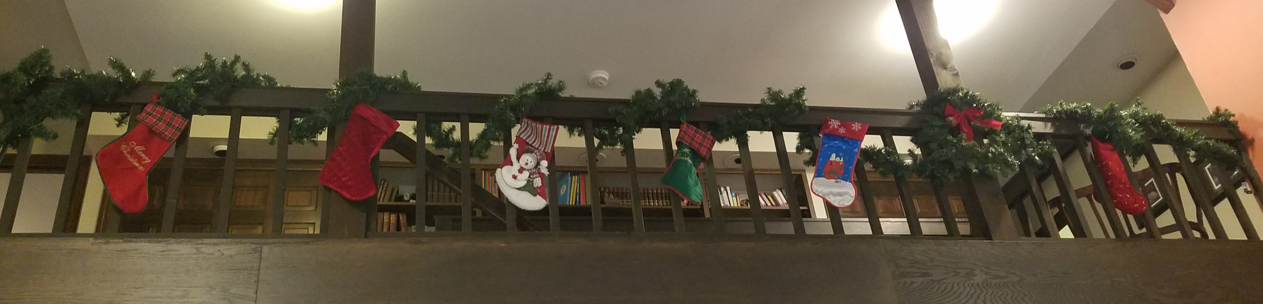
- Decorating done!  Our Guests Are 5-Star!  We owe you a big “Thank You!” As you know, we often ask first-time guests why they chose Shane Acres. Most say it was because when they looked us up online, all of our guests have rated us “5-Stars.”  So we thank you for your very kind reviews. In turn, we can honestly rate YOU as the best! It’s a pleasure to serve you. So we pledge to work hard to treat each new visitor right, because they just might be someone you referred to us, and we want to make you proud.  - Thank you to our friends and guests Carol, Dave, and Debbie for helping us set up and decorate our 12-foot Christmas Tree. “It looks like a Hallmark Movie in here, again”, said Debbie as she stepped back to take it all in.  Thanks to a couple of guests from Hortonville  We’ll be on an African mission trip next month  At breakfast CJ and Lisa told us about their trip to a mission in Kenya – HEART, which is Health Education Africa Resource Team.  HEART is a Christian humanitarian charity empowering the people of Africa to survive the HIV/AIDS pandemic by providing medical care, education, and income generating activities to create a healthy, sustainable, disease-free life. HEART provides hope and empowerment to over 100,000 people in Kenya.  HEART projects create jobs, nutrition and medical care in a country facing 70% unemployment; prevents child abuse and abandoned infants; gives goats to children to milk for money to buy uniforms required to attend school. And so much more!  HEART has received international recognition, including the Portraits of Compassion award from President  - Contact Us  Shane Acres Country Inn  Bed and Breakfast  N4589 Primrose Lane  Juneau, WI 53039  920-341-3004  shaneacresllc@gmail.com  www.shaneacrescountryinn.com | Brand New! Shane Acres  Souvenir Coffee Mugs!  We ordered just a few Shane Acres mugs, to see if you’d want a souvenir of your visit or to give as a gift to a friend heading for Wisconsin.  Just arrived today, in limited quantity and offered at about our cost. Only $15 includes cup, shipping and sales tax. If you are interested, drop us a note at shaneacresllc@gmail.com or call (920) 341-3004.  George Bush. In 2012, Dr. Jill Biden visited this mission to recognize HEART’s effective income-generating activities.  Jackie and Richard leave for Kenya Jan. 24th for two weeks as HEART volunteers, joined by Jackie’s sisters Shirley and Connie Jo. Like Jackie, both are in nursing. Learn more at www.//africaheart.com.  (Shane Acres will remain open for guests during this time.)  We ordered just a few Shane Acres mugs, to see if you’d want a souvenir of your visit or to give as a gift to a friend heading for Wisconsin.  Just arrived today, in limited quantity and offered at about our cost. Only $15 includes cup, shipping and sales tax. If you are interested, drop us a note at shaneacresllc@gmail.com or call (920) 341-3004.

