- November, 2019  10% off  your next stay  The leaves are changing colors and have been FALLing from the trees! Come enjoy a serene stay in the middle of nowhere.  Call us soon to reserve your suite before December 31, when the Fall discount ends.  “Everything about this property is beautiful and comfortable and we all felt right at home.”  -Anonymous  - Social Media  https://www.facebook.com/pg/shaneacrescountryinn/  https://www.instagram.com/shaneacrescountryinn/ | Simply Shane  Welcome  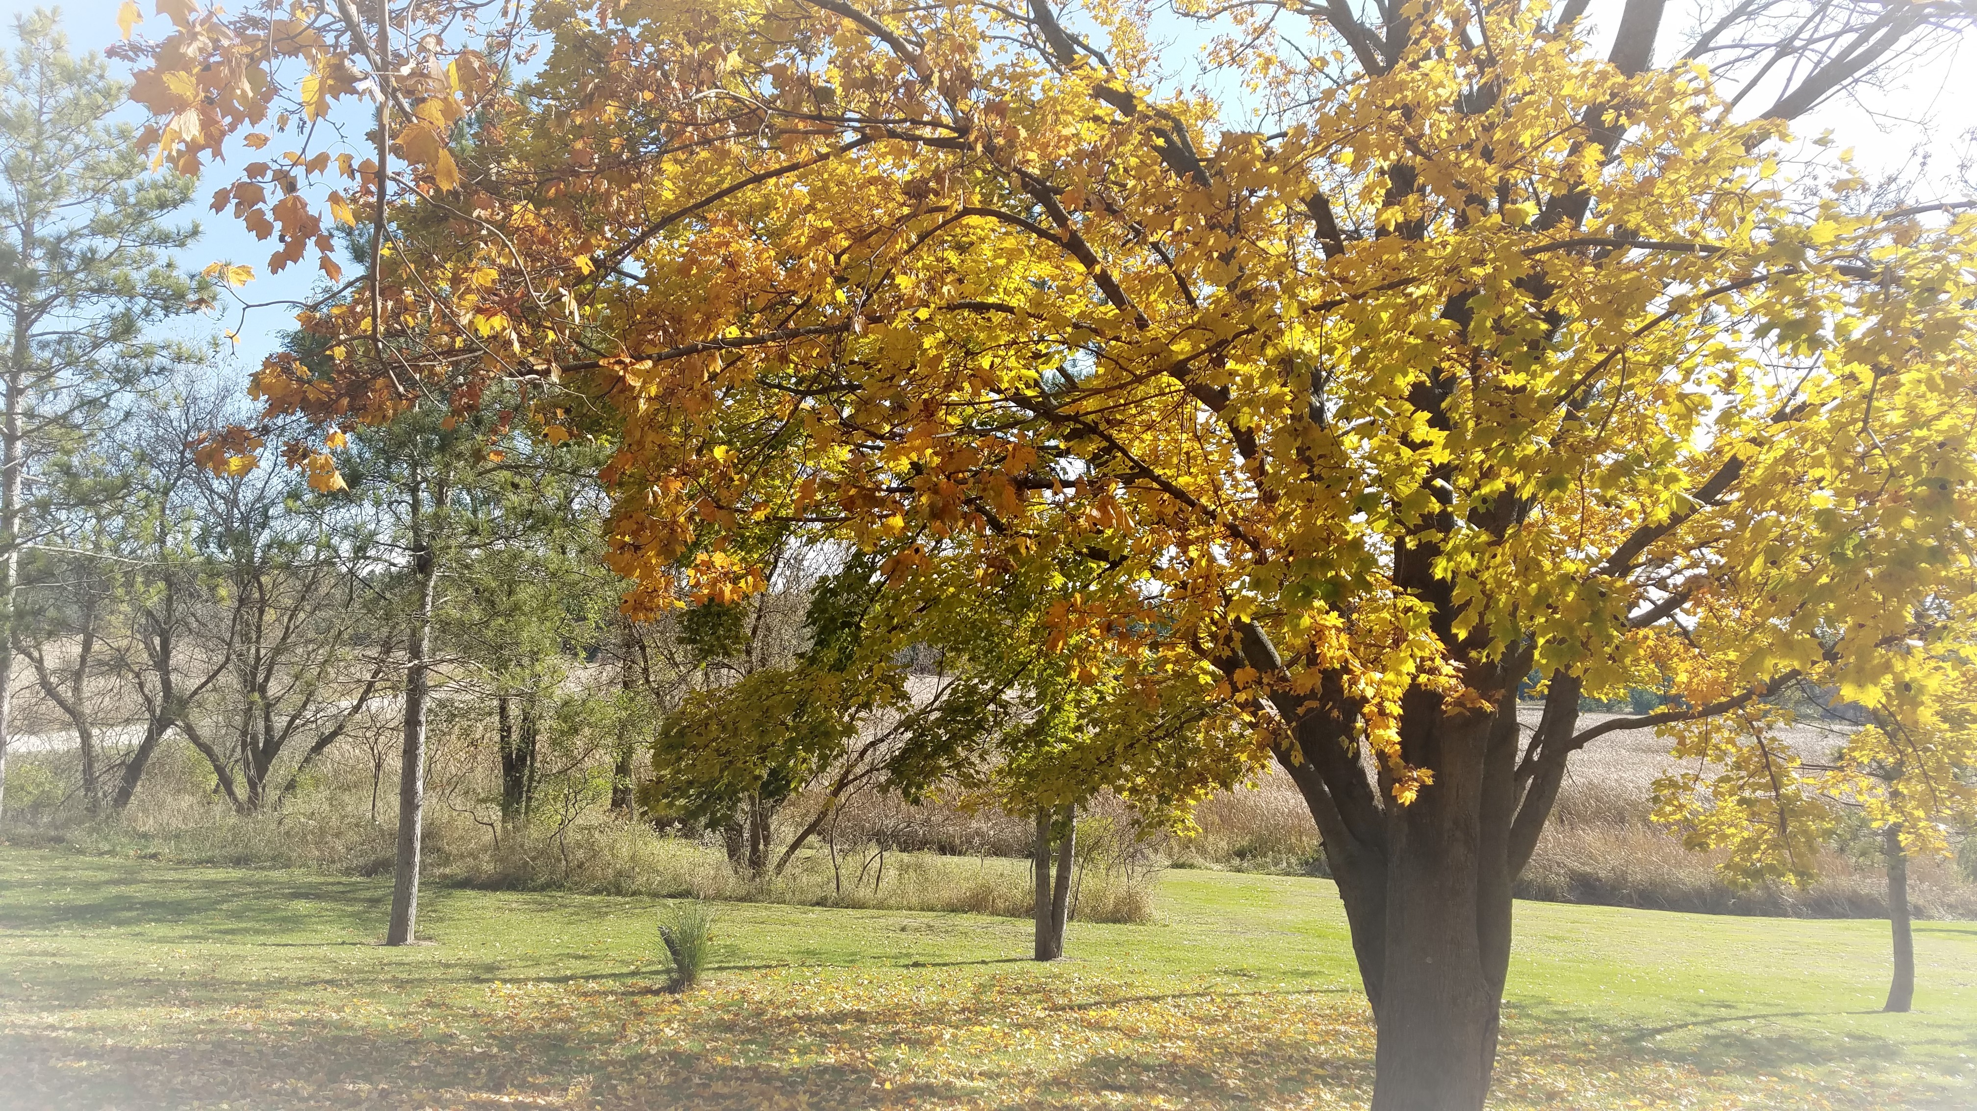  It’s officially November and the sugar maple trees are almost bare! Yesterday this tree was full of color. Today the wind is blowing and it’s raining leaves! Soon this tree will have a layer of snow. Oh, yes, I just said that ‘s word (snow).  The sugar maple is truly a year-round beauty! In the summer it is full of green fan-shaped leaves that provide much shade; in the fall it is a display of beauty as the leaves change color from green to orange to bright yellow; in the winter it holds the snow and offers an angelic picture; in the spring the sugar maple is a place for returning birds to perch. I hope you will smile the next time you pass a sugar maple .  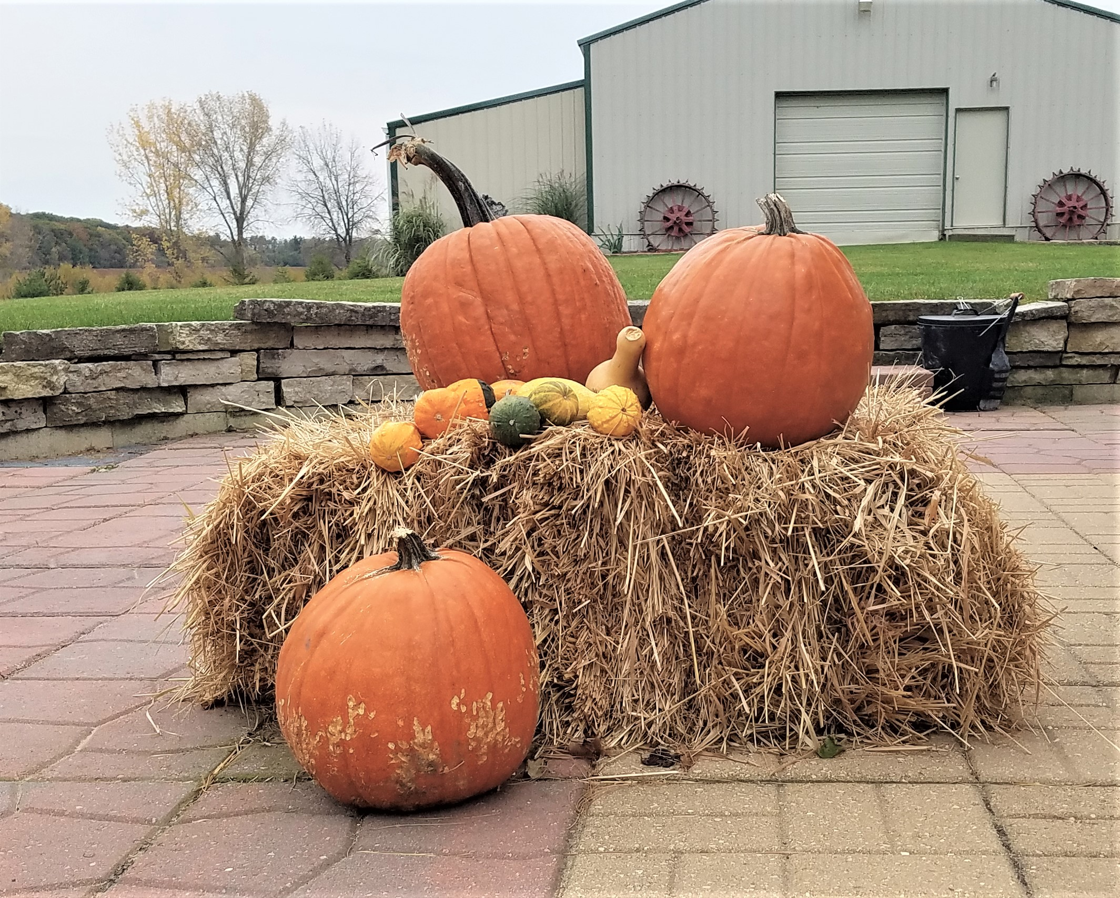  This pumpkin display has replaced the flower containers around the pool.  Did you know pumpkins grow on 6 of the 7 continents? They grow in Alaska, but not in Antarctica.
- Remember when  - Remember when everyone could fit around the table for holiday dinner? This year bring your family together again with Thanksgiving at our house. There’ll be room for everyone around our huge dining room table. Best of all, family members who traveled can stay overnight. No more late-night drives to get home!  - Contact Us  Shane Acres Country Inn  Bed and Breakfast  N4589 Primrose Lane  Juneau, WI 53039  920-341-3004  shaneacresllc@gmail.com  www.shaneacrescountryinn.com | Snow tubing, Skiing, and Snowboarding:  Looking for a very special holiday get-together? It’s the largest snow tubing park in the world . . . and it’s just 35 miles from Shane Acres! Sunburst at Kewaskum offers great family fun, with skiing, snowboarding and snow tubing runs.  A great ski weekend is closer than you think! Seven great ski hills just minutes away! Enjoy Christmas Mountain, Cascade Mountain and Devil’s Head . . . all within an hour’s drive from our bed and breakfast inn. Little Switzerland, Heiliger Hugel and Ausblick are even closer, about a half hour! Make it a weekend your family won’t soon forget. Great fun, great food and the cozy warmth of Shane Acres.  Local Events  Come join us Nov. 30th for Watertown’s Annual Christmas Parade of Lights. This is no small parade! Hundreds of units – bands, live music, unique parade units and of course lots and lots of lights! Visit Santa in his house after the parade. Then come back to Shane Acres for a cozy night around the fire with holiday music, marshmallows and awesome decorations!  Got tickets for HAMILTON? If you’re heading to the Marcus Center, make it a spectacular experience by staying the night at Shane Acres Country Inn.  There’s lots happening nearby this fall, including the Holiday Folk Fair International at State Fair Park. That’s also the site for Trainfest, the largest model railroad show in America. Mannheim Steamroller comes to the Riverside Theatre Nov. 16th.  Plan Ahead  2020 is not far away! Reservations are already filling the calendar. The Democrat National Convention is in Milwaukee July 13-16. The Oshkosh Fly-In, July 20-26, is the world’s largest private aviation show, and Whistling Straights Golf Course hosts the Ryder cup, Sept. 25-27. (No reservations are available at Whistling Straights Sept. 19-27).  As we reflect on our blessings this year, we are truly honored you spent a moment of your life with us. Thank you!

