- January 2020  Save 10% on your  next getaway!  Beat the winter blahs. Sneak away for a weekend at Shane Acres. Come enjoy a serene stay in the middle of nowhere.  Call us soon to reserve your room or suite and rediscover serenity.  “What a super relaxing place, my week was outstanding!”  -Anonymous  - Social Media  https://www.facebook.com/pg/shaneacrescountryinn/  https://www.instagram.com/shaneacrescountryinn/ | Simply Shane  Save an Extra 20% during Our Kitchen Remodeling  In the middle of nowhere, there’s so much to do!  TRAILS, HIKING, CAMPING AND NATURE  Next to Wild Goose State Trail, Shane Acres is great for hikers, bicyclers, horseback riders, leashed pets, cross-country skiers, snowshoeing, snow-mobiles and ATVs. Not far are Kettle Moraine State Forest, Glacial Drumlins.  There’s Horicon Marsh, the largest fresh-water cattail marsh in the U.S. Known as the “Little Everglades of the North,” Horicon Marsh was formed by a glacial lake and is part of the Ice Age Reserve.  Guests will find over 219 species of birds and waterfowl, including magnificent trumpeter swans returning from near (Continued on page 2)  extinction and a 100-year absence from the marsh. You’ll see egrets, herons, cormorants, sandhill cranes, several species of migrating ducks, tundra swans, and Canada Geese by the thousands. Get four seasons of outdoor fun, including water skiing, ice fishing, sailing, boating, canoeing, swimming and duck hunting. There are enough trout, walleyes, muskies, northern, bass, catfish, perch, crappies, bluegills and other pan fish in the county's waters to keep the anglers coming back for more. Boats, canoes, tackle and bait are available from outfitters throughout the county, and public and private boat ramps provide easy access to great fishing adventure.  SPORTS  Erin Hills, the site of the 2017 U.S. Open, is just 20 miles away, with many other excellent courses nearby. With Milwaukee and Madison minutes away, cheer on the Milwaukee Brewers, Bucks, or the University of Wisconsin Badgers. Green Bay’s Lambeau Field is just over 90 minutes away. Auto racing is big here. Hunters enjoy the abundance of deer, rabbits, squirrels, foxes, pheasants, geese, other fowl and small game to challenge every hunter.  MUSEUMS, ART, ANTIQUES AND COLLECTIBLES  Founded before Wisconsin was a state, the area preserves memories in countless galleries, from auto museums to dairy and historic museums. Just 40 minutes away, the Fireside Dinner Theatre is recognized internationally for Broadway-quality performances. Casual browsers and serious collectors will enjoy the antiques, collectibles, furniture, linens, vintage clothing, quilts lamps, fine art, art glass, dolls and recent treasures offered by more than 230 dealers in antique and collectibles shops and malls throughout Dodge County. Here, too, shoppers will find one of Wisconsin's oldest and largest craft and hobby shops, quilting, sewing and fabric stores, craft outlets and enclosed general merchandise malls.  FINE DINING  Whether you want to dine in style or eat on the run, there's a Dodge County dining establishment to serve you, including an historic inn, rated one of Wisconsin's ten best by the Milwaukee Journal/Sentinel's food critic, family restaurants featuring fresh Dodge County ingredients and home cooking "better than Grandma's", fast food outlets, old-fashioned drive-ins and authentic ethnic restaurants.  OUTDOOR CONCERTS, FAIRS AND FESTIVALS  From Milwaukee’s Summerfest-- the world’s largest music festival --to the Oshkosh EAA Fly-In, you’re just minutes away from great music, food and fun. Wisconsin Dells and Madison’s Concerts on the Square are a short drive away.  AND SO MUCH MORE  Our kitchen is being remodeled, so you’ll save a full 20% on all rooms and suites! We’ll still be serving breakfast, but starting Monday, Jan. 20th, workers will be putting in a whole new kitchen. During that time, we’ll have a temporary kitchen and dining area set up, so it will still be breakfast as usual. But, to thank you for any inconvenience, we’re giving an extra 20% discount Jan. 20th through Feb. 9th. Enjoy our queen or king-size rooms for just $68 plus tax. Indulge in the comfort of a full-size suite at only $110.40 plus tax. And you still get a delicious Shane Acres country breakfast! Special applies only to reservations made directly through our website, shaneacrescountryinn.com or by phone at (920) 341-3004.  While we’re in Africa, Shane Acres will be open as usual!  Book Direct &Save Year-round  Sometimes we post special discounts on Expedia, Booking.com and the other online travel agencies. But, we offer those same discounts to guests who make reservations on our own website. Actually, you always get the lowest rate when you book direct on shaneacrescountryinn.com. Just tell us the deal you found on Expedia, Booking.com, Air BnB or any other online travel agency, and we will be sure to match it! Book direct at our website and save!  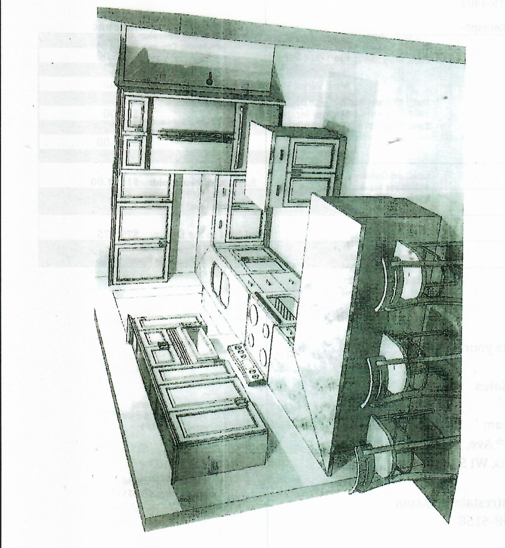Breakfast is half the reason for a BnB. So we’re getting all new appliances and more counter space . . . to make your breakfast even better!
- My whole family came for Christmas and we still found enough beds for everyone!  (Continued from page 1)  So Much to Do!  extinction and a 100-year absence from the marsh. See egrets, herons, sandhill cranes, ducks, tundra swans, and Canada Geese. Get four seasons of outdoor fun-- water skiing, ice fishing, sailing, boating, canoeing, swimming and duck hunting. There’s walleye, trout, muskies, northern, bass, catfish, perch, crappies and bluegills. Local outfitters have boats, tackle/bait, and public boat ramps provide access to great fishing adventure.  SPORTS  Erin Hills, site of the 2017 U.S. Open, is just 20 miles away. Cheer on Milwaukee Brewers, Bucks, or the UW Badgers. Green Bay Lambeau Field is 90 minutes away. Auto racing is big here. Hunters enjoy the abundance of deer, rabbits, squirrels, foxes, pheasants, geese, and small game to challenge every hunter.  MUSEUMS, ART, ANTIQUES AND COLLECTIBLES  Explore auto, dairy and historic museums. Fireside Dinner Theatre is recognized worldwide for Broadway-quality performances. Casual and serious collectors will find antiques, collectibles, furniture, linens, vintage clothing, quilts lamps, fine art, art glass, dolls and recent treasures at 230 collectible shops in the area.  FINE DINING & SUPPER CLUBS  Dine in style or eat on the run; there's a restaurant to serve you, even a historic inn, rated one of the state's 10 best by the Milwaukee Journal/Sentinel's food critic.  CONCERTS, FAIRS, FESTIVALS  From Milwaukee’s Summerfest-- the world’s largest music festival --to the Oshkosh EAA Fly-In, you’re just minutes away from great music, food and fun. Wisconsin Dells and Madison’s Concerts on the Square are a short drive away.  - Host your next family get-together at Shane Acres. We can easily sleep 20, and other family members are welcome to drop in too. For a holiday event or an outdoor party and barbecue, we’ll fit our inn to meet your family’s needs.  - Contact Us  Shane Acres Country Inn  Bed and Breakfast  N4589 Primrose Lane  Juneau, WI 53039  920-341-3004  shaneacresllc@gmail.com  www.shaneacrescountryinn.com | 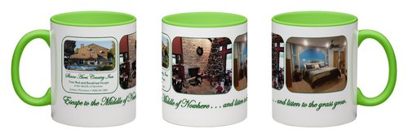  Brand New! Shane Acres  Souvenir Coffee Mugs!  Try this gift idea. Slip a gift certificate inside one of our souvenir mugs to surprise a friend or loved one with a weekend at Shane Acres.  Best of all, the mug is free with a weekend gift certificate for use during January through March. Mugs available separately at $15 plus tax.  Special Occasions Are More Special at Shane Acres  Birthdays are better, anniversaries are more unforgettable. Just tell us the event you’re celebrating as you make occasion the best ever! Enjoy a romantic getaway. Or bring your whole family and host a special birthday or graduation party. Stay the night and invite your child’s best friends to a party at Shane Acres the next day.  SPECIAL ALERT: Summer dates are filling up fast  Planning a visit to Shane Acres this summer? Please consider making your reservations now.  We expect to have a very full summer. June has Summerfest and the NBA Champion-ships. July brings the Democrat National Convention and Oshkosh’s EAA Fly-In. August offers the Wisconsin State Fair. September brings the Ryder Cup at Kohler.  Remember, returning guests save an extra 10% by booking direct on shaneacrescountryinn.com.

